motion.jpg

***Human Resource Agency Administration & Program Office***

*420 E. Laurel Street*

*Willows, CA 95988*

*Telephone: 530-934-6510*

*Toll-Free: 1-800-287-8711*

[www.cgtcap.org](http://www.cgtcap.org)

Bill Wathen, Rehabilitation and Weatherization Program Manager

(530-934-1468)

David Allee, Business and Employment Services Program Manager

(530-934-1532)

Lucy Hernandez, Housing and Community Services Program Manager

(530-934-1452)

Korri VonSeggern, Supervising Accountant

(530-934-1461)

Christine Zoppi, Deputy Director (530-934-1458)

Scott Gruendl, Director

(530-934-1413)

*“Individuals, Families and Communities; Successful, Safe and Strong”*

***Promise of Community Action***

***Community Action changes people’s lives, embodies the spirit of hope, improves communities, and makes America a better place to live.***

***We care about the entire community, and we are dedicated to helping people help themselves and each other.***

**Living the Promise of Community Action: *The New Reality***

Colusa, Glenn, & Trinity Community Action Partnership Annual Report

2011 / 2012

**Director’s Message**

Each year I take the opportunity to reflect on what has happened in the past in an effort to make appropriate goals for the year and into the future. There is so much change afoot, from a lack of opportunity due to the economic downturn, to realignment, to health care reform. Agencies face increasing costs, greater demands, and less revenue. Times are no longer business as usual. Therefore, I have arrived at the theme for this report, **Living the Promise of Community Action: The New Reality.**

The national Community Action Partnership recently released a special report, *Facing the New Reality: Preparing Poor America for Harder Times Ahead*. The report discusses some alarming scenarios that will affect people across the country, and are already affecting many here in the North State. This includes several potentially catastrophic factors such as resource depletion (including peak oil/water), climate change, and ongoing economic instability. This poses a massive challenge to every dimension of modern life, from transportation operations to energy sources.

The causes of, and solutions to, these factors are being debated among policymakers and legislators, but their impacts on local families and communities can be readily observed. The precarious economic situation is perhaps the most imminent and persistent challenge in our region, as job opportunities remain minimal. Further economic contractions will not only imperil families in danger of unemployment and poverty, but will also affect government services as the revenue base shrinks. In this New Reality, Community Action Agencies and Social Service Programs may need to shift from eliminating poverty to creating new understandings and new forms of wealth in a contradicting economy. These urgent times require our rapid and thoughtful strategic actions and responses. Many of us have spent decades showing the results and tell the success stories of people and families who have overcome poverty. Yet, now more than ever, we need to increase our efforts, but change our approach.

As one contributor to the New Reality report notes, the mission of social service agencies will out of necessity “shift from seeking a fairer distribution of abundance to the much harder task of managing scarcity.” This is a difficult but not impossible task, and as we live in a region of agricultural and entrepreneurial abundance, we can pool our local talents and resources, and help our communities find opportunities in those areas.

Managing this new reality will take a solid understanding of the principles and actions that are committed to changing the lives of people, and embodying a true spirit of genuine hope and empowerment in our local communities-a task that the Colusa, Glenn, Trinity CAP is ready to accept and had already recognized over a year ago when we created a goal of shifting from poverty programs to community development. Your Community Action Partnership follows no path, we blaze new trails that others follow. I look forward to our continued successes as we skillfully surf the wave of change!

**Scott Gruendl, Director**

You may view the entire New Reality Initiative at:

<http://www.communityactionpartnership.com/index.php?option=com_content&task=view&id=82&Itemid=277>

BOARD OF DIRECTORS

Category I – Elected Officials

* **Denise Carter**, Board of Supervisor, District 5 – Colusa County: 02/2009-Present
* **Mark Marshall**, Board of Supervisor, District 3 – Colusa County: 01/2001-Present
* **Mike Murray**, Board of Supervisor, District 4 – Glenn County: 01/2009-Present
* **Steve Soeth**, Board of Supervisor, District 3 – Glenn County: 01/2009-Present
* **Roger Jaegel**, Board of Supervisor, District 3 – Trinity County: 01/2011-Present
* **Debra Chapman**, Board of Supervisor, District 4 – Trinity County:01/2011-Present

Category II – Representatives of Economically Disadvantaged

* **Minnie Lawrence**, Former County Provider & Advocate for Senior Citizens – Colusa County: 01/1992-Present
* **Debbie Moutter**, Orland Family Parent Board – Glenn County: 02/2009-Present
* **Rev. Philip Zabell**, Glenn Communities Working Together – Glenn County: 12/2003-Present
* **Al Schroeder**, Hayfork Community Center Volunteer & Employee – Trinity County: 03/2008-Present
* **Rev. Geraldine King**, Holy Trinity Lutheran Church – Trinity County: 12/2009-01/2013
* **Rev. John Vafis**, St. Stephens Episcopal Church -Colusa County: 10/2012-Present
* **Ed Rios**, Migrant Farm Housing-Colusa County: 11/2007-08/2011

Category III – Representatives of Private Enterprise

* **Lora Ceccon**, One-Stop Employment Resource Center – Colusa County: 12/2005-Present
* **Elizabeth Kelly**, Health & Human Services – Colusa County: 09/2010-Present
* **John Minniear**, Former County Housing Manager, Licensed Contractor – Glenn County: 09/2002-Present
* **Joanne Overton**, Former Board of Supervisor, Business Owner – Glenn County: 01/1997-Present
* **Sandy Bechtold**, Lic. Real Estate Agent & Office Manager, Cell Tower Project Lead – Trinity County:05/2007-Present
* **Linda Wright**, Health & Human Services – Trinity County: 01/1997-Present
* **Donna Dennis,** Health & Human Services – ColusaCounty: 06/2010-Present

***Impacting Lives***

The Colusa-Glenn-Trinity Community Action Partnership (CGTCAP) is administered by the Glenn County Human Resource Agency (HRA), an intergrated Social Services and Community Action Agency. This unique blend of services allows the coordination of mandated federal programs with the flexibility and responsiveness of Community Action programs. The following success stories remind us of our purpose and the importance of the work we do for families in our local communities.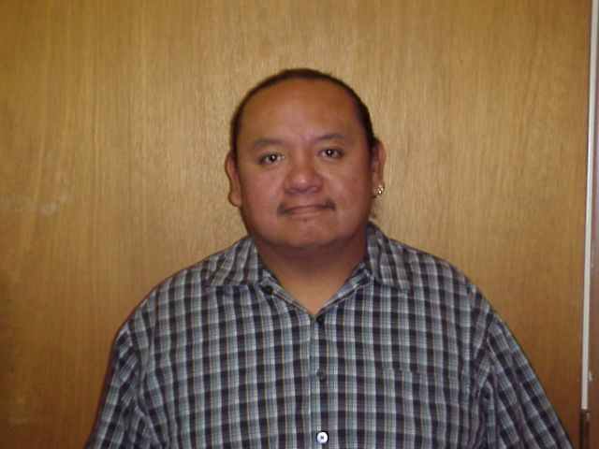

*“I want to thank Glenn County Employment Services WIA Program and my worker Linda Johnson. Without them I would not have been able to graduate from the Butte College Alcohol and Drug Studies Program. It has been my goal for many years to become a Drug and Alcohol Counselor. I took classes when I could as I was working full-time. Last year I was laid-off at my job due to budget cuts, and in that moment of despair the WIA program helped me to find hope and gave me encouragement to take the time to finish my education and complete my certificate. As a result of completing my education plan and interning at Cache Creek Lodge Treatment Facility, doors were opened to employment. I am now employed full-time as a Substance Abuse Counselor at Cache Creek Lodge. I am very grateful for being a participant in the WIA program, and feel very fortunate to be successfully employed in the field that I went to school for. Again, my sincere thanks to Linda and the WIA program.” ~~Irvin Watkins*

*(WIA Programs serve adults, as well as “dislocated workers” (those who have recently experienced layoff from employment) with job-seeking services, in-depth career assessment and (where appropriate) re-training into demand occupations.)*

*A homeless, senior couple (both age 57), came to the Human Response Network for homeless assistance. The couple was staying at a campground in a tent and occasionally staying at their daughter’s house to shower. They received SSI and had no savings for first month’s rent or deposit for a rental unit. The couple was assisted in finding a rental to fit their budget, and over a three month period was assisted with $1400.00 in rental and deposit funds. Through case management, financial literacy, and household budgeting, the couple has paid their utility and rental deposits in full. By cutting costs and budgeting, they are now able to meet daily living expenses. ~Confidential*

*(Homelessness Prevention and Rapid Re-Housing (HPRP) funding provides low income clients with assistance in paying their security deposit or assists them with rent on a short-term basis.)*

*A very pleased Trinity County resident from Lewiston called to demonstrate her satisfaction with the work completed by the Weatherization Team, here’s what she said, “ What I am calling in regards to is a major compliment, and I mean major! The professionalism and the politeness of the gentlemen! They came up here and helped me with keeping my place warm and improving it in different ways. They were so informative and they did their job outstanding. I want to make sure that the supervisor or the boss, the director, or whoever is in charge of these men, know what an outstanding job they did. Thank you from the bottom of my heart for this program, and I pray, that I won’t need your guys up here in the near future, but if I ever need you again…..*

*I cannot recommend you guys any higher than that. You are better than the commercial workers…..you are very efficient, pleasant, thorough and worker as a team. Thank you!*

*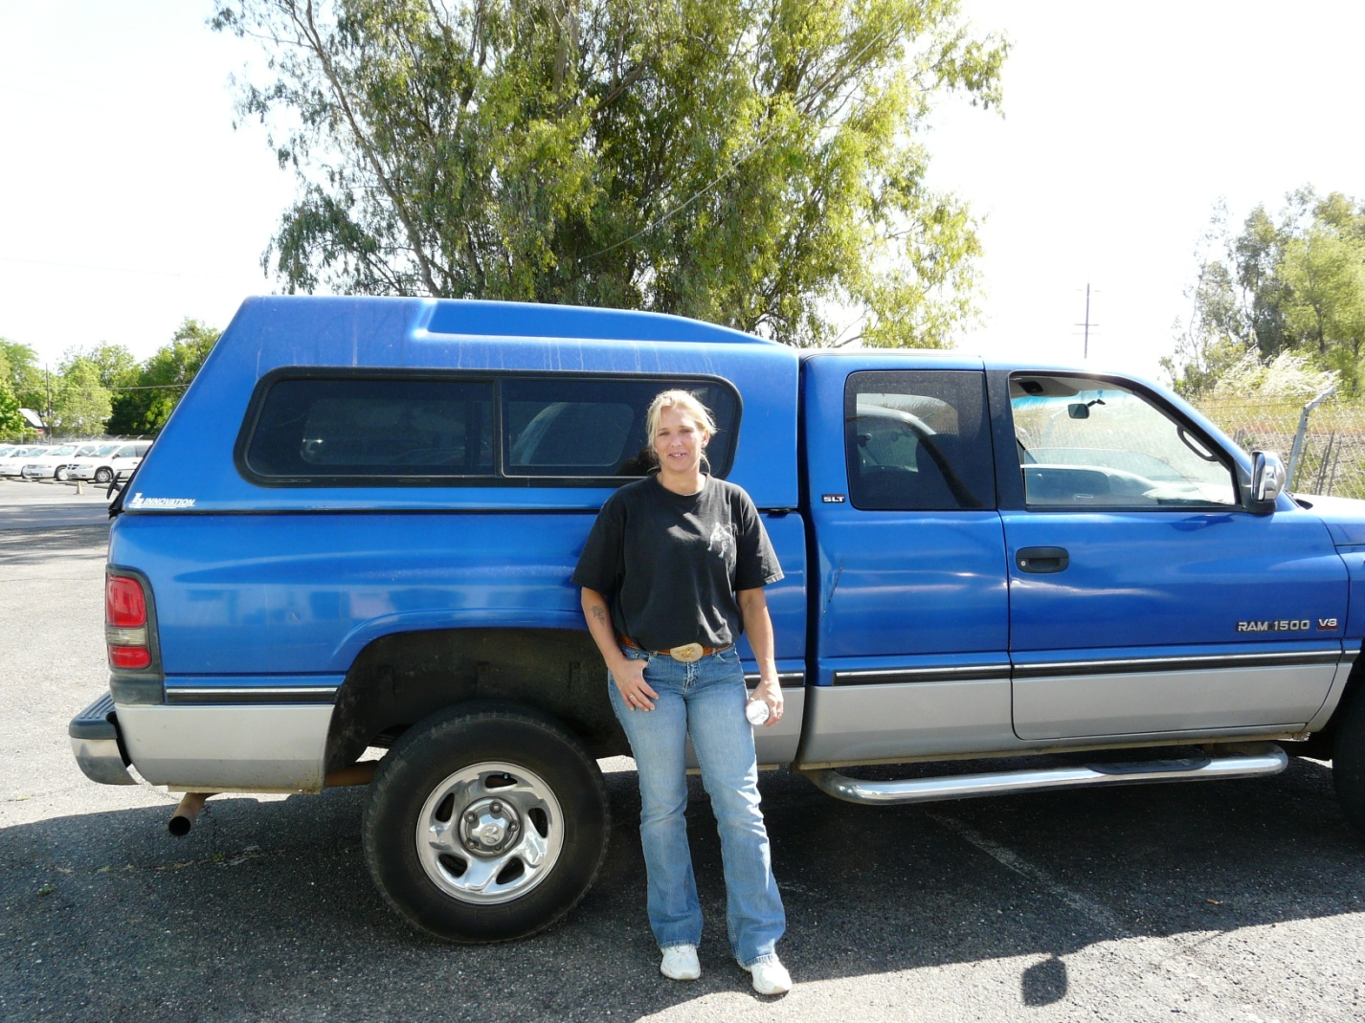Shilee Cloud is one of the successful participants in the Community Re-Entry Work (CREW) pilot program. Shilee was facing a 17-year prison sentence, but was given another chance, and has made the most of that opportunity. Upon release Shilee enrolled in the CREW program to start her transition to a better life.*

*“Getting into the CREW program and getting into the Unity in Recovery house helped me stay on track. Having my 17-year suspended sentence gave me a big push to change. My last reason were my dogs, I wasn’t going to lose them to anybody.” Shilee’s advice to people going through the same type of transition that she went through is to not quit and work hard. She likes to earn her living and wants to see other success stories from the CREW program. Within a few months of joining CREW, Shilee began attending college, and has a part-time job and owns her own small business.*

*Finding a job in the North State can be challenging, especially in current economic conditions. For individuals being released from institutions there are additional significant challenges, such as being released into an area where they have no family support system, no shelter or food, and limited or marginal job skills. To Shilee, CREW made a huge difference in her life because in addition to helping her with employment, CREW also provided rental assistance, allowing her to concentrate on job skills and employment rather than finding shelter.*

*(CREW is a pilot program designed to assist individuals returning from institutions (jails, prisons, hospitals) with finding housing and food, acquiring job skills, and transitioning back into society.)*

**Building Hope for California’s Rural Counties -- Glenn County Community Re-Entry Work (CREW) Program Receives “Innovative Program of the Year” Award for the State of California.**

On September 5, 2012, the California State Association of Counties (CSAC) awarded the Glenn County Community Re-Entry Work Program (CREW) its highest honor-that of the most innovative project in the state for the year. The reason

for ranking so highly, the CREW Program voluntarily brings together multiple service providers to creatively and successfully meet the needs of AB 109 with limited resources.

The State of California’s 2011 Public Safety Realignment Legislation (Assembly Bill 109) mandates returning non-violent prisoners from the state correctional system to the county level. For rural counties with fewer resources and support networks, this presents considerable challenges for impacted communities.

CREW was conceived to address these challenges collaboratively, bringing together multiple agencies and services throughout Glenn County. The primary goal for CREW is to assist the re-entry population in returning to the community in a successful manner while reducing incidents of recidivism. This includes helping them access stable housing and food, providing job counseling, work placement, attaining education and case management, in order to help them return to the workforce and become self-sufficient.

The strength of CREW lies in the collaboration of multiple teams to integrate services. County agencies and services recognize the potential impact to the entire community, and have pulled together to build capacity, and to create opportunities for participants to return to their communities. This program allowed for savings to the County programs and reducing impacts of recidivism in the local jails/prisons.

“The creation of the CREW program is proof that inter-agency collaboration with a focus on investing in people can only make our community a better place.  Historically, individuals released from the State Prison System were afforded few, if any, resources to change their lives in a meaningful way.  In Glenn County we have created an environment for people to make positive changes for the betterment of themselves, their families and our community.”-Brandon Thompson, Glenn County Chief Probation Officer

CREW finished its initial year as a pilot program in June 2012 with impressive results! Of the ten participants in the pilot program, eight (8) have completed the program successfully, 50% of the participants became gainfully employed, and 20% are in the process of starting their own businesses. California’s recidivism rate is approximately 65%, the highest rate in the country. The CREW program has had an 80% success rate with the re-entry population and only a 20% recidivism rate during the pilot program, which has been a welcome success. There are currently 12 participants with growth to 35 underway. To date, CAP staff have conducted 20 presentations and trainings across the state.

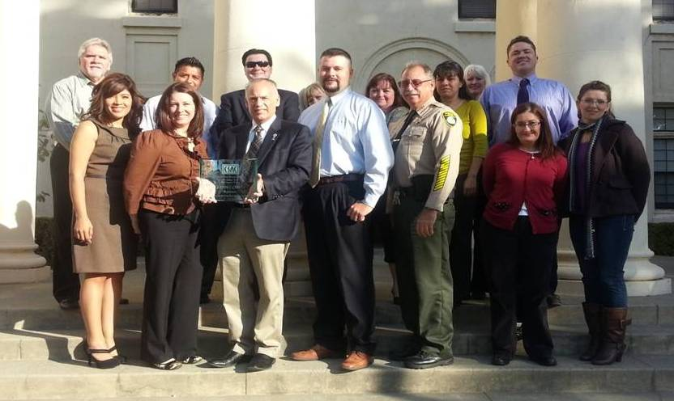

***Scott Gruendl, HRA Director, accepting the CSAC Innovative Program of the Year Award from Elizabeth Howard Espinosa, Senior Legislative Representative, with the CREW Program’s collaborative partners from Employment Services, Business Services, Probation, Housing & Community Services, Sheriff’s Office, Child Support Services, Mental Health, Office of Education, Drug & Alcohol Services, Social Services, Unity in Recovery and Local Business.***

***View all of the Challenge Award Recipients at:*** [***http://www.csac.counties.org/article/2012-challenge-award-recipients***](http://www.csac.counties.org/article/2012-challenge-award-recipients)

***View a video of the CREW Program at:*** [***http://www.csac.counties.org/smart-justice-california-counties***](http://www.csac.counties.org/smart-justice-california-counties)

***Outcomes for 2011-2012…***

**Employment Services**

|  |
| --- |
| 59 unemployed people obtained jobs |
| 38 demonstrated a measurable increase in skills/competencies required for employment |
| 18 achieved “living wage” employment and benefits |
| 22 Glenn County employers benefited from the Subsidized Employment Program (SEP) |
| 33 SEP employees were placed in public and private sector employment with an average wage of $12.65/hour |
| 8 SEP employees remained employed upon the end of their contract |
| 4 persons started their own business with Microenterprise assistance |

**Weatherization**

|  |
| --- |
| 1,189 households received weatherization services to reduce energy and heating fuel consumption |
| $2,371,983 of leveraged funds from DOE, LIHEAP, CalWORKs and ESAP were utilized to decrease energy and heating fuel consumption and improve the health and safety of homes |
| 1,390 households received energy education and conservation techniques to reduce energy costs |
| 660 households received CalFresh outreach and access information. |

**Housing & Community Services**

|  |
| --- |
| 127 households received Emergency Shelter or Transitional Housing |
| 434 families were helped to secure safe housing |
| $797,445 in Section 8 rental assistance was paid to ensure affordable housing |
| $418,204.92 was utilized to provide stable housing through the Homelessness Prevention & Rapid Re-Housing Program (HPRP) & Federal Emergency Shelter Grant (FESG) |
| 4,105 individuals received food to get through an emergency situation |
| 2,792 families here helped to avoid utility termination or a fuel crisis |
| $1,032,509 in payments made to help households with reduce their energy costs |
| 11,038 hours were given by community volunteers in 2011 |
|  |

**Services Provided in Partnership**

|  |
| --- |
| Glenn County  Glenn Communities Working Together   * 300 families and individuals were helped by the Volunteers in Tax Assistance (VITA) Program (2011) * $103,013 in total dollars brought to households through VITA |

|  |
| --- |
| Trinity County  Human Response Network   * 200 households received CalFresh outreach and access information |
| Trinity County  Human Response Network   * 6,391 bed nights provided * 27 families, totaling 64 people were housed |

# 2011/2012 FISCAL REPORTS

|  |  |  |  |  |  |  |
| --- | --- | --- | --- | --- | --- | --- |
|  |  | **2011-USE OF FUNDS** | | | |  |
|  |  |  |  |  |  |  |
|  |  | **1. WEATHERIZATION (WX)** | $1,173,699 | 18% | WX |  |
|  |  | **2. EMERGENCY SHELTER/HOUSING (EH)** | $2,010,481 | 31% | EH |  |
|  |  | **3. HOUSING REHABILITATION (HR)** | $115,747 | 2% | HR |  |
|  |  | **5. FUEL/UTILITY ASSISTANCE (FA)** | $762,066 | 12% | FA |  |
|  |  | **6. YOUTH PROGRAMS (YP)** | $381,353 | 6% | YP |  |
|  |  | **7. EMPLOYMENT & TRAINING (ET)** | $1,295,730 | 20% | ET |  |
|  |  | **8. COMMUNITY SERVICES (CS)** | $584,830 | 9% | CS |  |
|  |  | **9. FOOD BANKS/NUTRITION PROG (FB)** | $81,838 | 1% | FB |  |
|  |  | **10. OTHER (SERVICE & VEHICLE DEPTS)** | $118,568 | 2% | OT |  |
|  |  |  | $6,524,312 | 100% |  |  |

|  |  |  |
| --- | --- | --- |
| **2012-USE OF FUNDS** | | |
|  |  |

|  |  |  |  |
| --- | --- | --- | --- |
| **1. WEATHERIZATION (WX)** | $1,249,454 | 25% | WX |
| **2. EMERGENCY SHELTER/HOUSING (EH)** | $930,646 | 18% | EH |
| **3. HOUSING REHABILITATION (HR)** | $49,267 | 1% | HR |
| **5. FUEL/UTILITY ASSISTANCE (FA)** | $658,801 | 13% | FA |
| **6. YOUTH PROGRAMS (YP)** | $371,760 | 7% | YP |
| **7. EMPLOYMENT & TRAINING (ET)** | $897,617 | 18% | ET |
| **8. COMMUNITY SERVICES (CS)** | $686,715 | 14% | CS |
| **9. FOOD BANKS/NUTRITION PROG (FB)** | $74,557 | 1% | FB |
| **10. OTHER (SERVICE & VEHICLE DEPTS)** | $156,251 | 3% | OT |
|  | $5,075,068 | 100% |  |

# Community assessment and priorities

With the assistance of **80 community members and service providers**, the following Priorities were established as a result of three (3) community meetings conducted throughout three priority communities within Colusa (Williams), Glenn (Hamilton City) and Trinity (Mad River) counties in May of 2011. In addition to the community meetings, two separate surveys were conducted by front-line and management level staff. Additional community assessment information was gathered from planning sessions held in conjunction with the development of the ten-year plan for the Dos Rios Continuum of Care, including associated homeless survey data gathered by CAP staff and CAP board members.

**Colusa-Glenn-Trinity Community Action Partnership Priorities**

1. Community Capacity Building -- support local non-profits & general community development
2. Job/business development & vocational training opportunities assistance
3. Outreach/marketing of existing CAP services to community – continue & enhance current exposure

# look what we have done...

Community Action staff coordinated efforts with community partners to help revitalize Hamilton City on September 22, 2012. A total of 13.21 tons of garbage was collected, over 100+ tires recycled, electronic waste and scrap metal. This was a community effort and it was a privilege to be part of a team that activates the community to come together to solve local issues collaboratively.

*A former U.S. Veteran had been released from Conservatorship and had nowhere to go. He was able to find a rental and received three months of Rental Assistance through Community Action’s Homeless Prevention and Rapid Re-housing program, which allowed him to find a stable living situation and save enough money to continue paying for rent and living expenses on his own. ~Confidential*

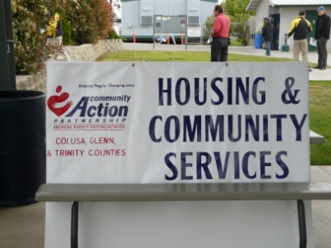The Community Action Partnership has expanded service capacity by partnering with the Colusa County One-Stop to place an employee in the town of Colusa to provide Community Action services such as housing assistance to the residents of Colusa County. The One-Stop provides employment services such as: basic skills assessment, résumé development, job skill development, vocational skills training, job search and placement, on-the-job training, and many other services. This partnership has allowed us to meet the goal of increasing access to services that promote self-sufficiency in the communities we serve.

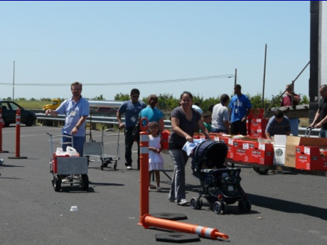Thanks to the efforts of the Community Action Agency of Butte County, Inc. and the Colusa-Glenn-Trinity Community Action Partnership, hundreds of people lined up in July and September 2011 for the Hamilton City and Orland Tailgate Food Giveaways. This event was extremely successful and gave away thousands of pounds of food to needy families. Again, we thank staff who helped make this event a true success!

*“It’s great to see all these families getting help. Children, women, and men are all smiling and they are all so thankful. I’m just glad I was able to be part of this event.” ~*Hamilton City resident and volunteer - Leonel Puga.

*“I cannot fully extend my gratitude with just a simple card. Everything that was done by the crew was great. I am very grateful for all the improvements done on my house; I smile everyday when I get home. You made a wonderful, positive difference in my life.”~Confidential*